Alaska Indoor Gardening Curriculum

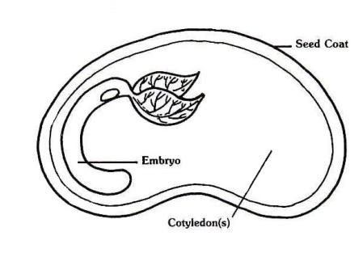
Plant Parts: Seeds

Author(s)/Source: Mel Sikes, Alaska Ag in the Classroom.
Adapted from “Seeds, Miraculous Seeds” by Debra Spielmaker, Utah Ag in the Classroom

Suggested Grade Levels: 3-6th grade

Time: 40-45 minutes

Teaching Goal: Students will learn the basic parts of seeds and what they need to grow into a plant.

Learning Objectives:
Students will be able to identify the process of growth and development from a seed to a plant.
Students will discover what's inside a seed, to predict how seeds will change after sprouting, and to observe the sprouting (germination) process.

Core Ideas:
- Plant Anatomy
- Plant Life Cycles
- Plant Dynamics (circulation and nutrient uptake)
- Germination
- Recording Scientific Data
- Standardized Science Measurements
- Drawing Conclusions from Experimentation (hands-on, observation, drawing, and note-taking)

Alaska State Science Standards: 3-LS4-4, 4-LS1-1, 5-LS1-1, 5-LS2-1, MS-LS1-1, MS-LS1-2, MS-LS1-4

NGSS Standards: 3-LS1-1, 4-LS1-1, 5-LS1-1, MS-LS1-1, MS-LS1-2

Background for Teachers:
What is inside of a seed? A new wildflower, a new vegetable plant, or new tree; and all it needs to grow! Will your students believe you? Seeds are relatively small, with the exception of coconuts, with a potential for growth into a productive plant or tree. How does such a small package contain such a potential? Seeds grow into new plants. Each seed has a seed coat and an embryo containing tiny leaves, a stem, and roots. The seed coat protects the embryo while a temporary food supply nourishes it, either as an endosperm packed around the young plant or stored in special leaves called cotyledons. Most seeds are either monocots, having one cotyledon (pronounced: cot-oh-lee-don), or dicots with two. Seeds remain inactive until conditions are right for them to begin to grow or germinate.

All seeds require oxygen, water, and the proper temperature range in order to germinate. Oxygen and moisture, initially taken in through the seed coat and later by the root, help the seed get energy from its food supply. Different types of seeds have specific temperature requirements and preferences for germination. Many seeds also require proper light conditions to germinate: some require light, while others are inhibited from germinating by light.

Seeds have their own source of nutrients, in the cotyledons or endosperm, to sustain them through early life, so they do not require additional nutrients. The proteins, fats, and carbohydrates stored for the benefit of the young plant are what makes seeds such a rich and vital food source for humans and other animals.

When a seed is exposed to proper conditions for germination, water is taken in through the seed coat. The embryo’s cells begin to enlarge, and the seed coat breaks open. The root emerges first, followed by the shoot, which contains the stem and leaves.

Materials Needed:
- Seeds: Soaked pinto beans and corn seeds.
- Seeds from store bought vegetables and fruits – ex. avocados, oranges, apples
- Paper towels
- Distilled water
- Small sandwich sized Ziploc bags
- Staplers
- Seed science experiment page
- Seed Parts Diagram
- Magnifiers
- Toothpicks
- Spray bottles
- Sharpies
- Masking tape
- Plastic cups, planting pots
- Plant tags
- Toothpicks
- Soil

Prep

Put the pinto bean and corn seeds into a jar and pour distilled water onto them. After 24 hours, remove the seeds and place them on a paper towel. The beans should be damp and easy to pry open with your fingernail. Place all the seeds in a Ziploc bag and put into fridge until you are ready for class. This should be done 24 – 48 hours before the class begins.
Procedure
1. Introduction
- Tell students that today they will be learning how seeds grow and develop into plants with the help of soil, water, sunshine, and carbon dioxide.
- Inform students that all plants start off as a seed and that all seeds have life in them, and they need energy and food to form a plant.
- Inform the students that a seed will not grow if they hold it on their hands or place it on the table.

2. Discuss how germination works. Write the word germination on the board.
Germination
Germinate is a big word. Does anyone know what that means? Germination refers to the process of a seed growing in to a plant. A seed is like a suitcase for the plant. It has everything it needs in order to begin to grow into the plant.

For germination to begin, the environment must be right.
The seed needs an adequate amount of:
- Water
- Oxygen
- Suitable temperature/heat
The first step in germination is for water to enter the seed coat, causing the seed to swell. The embryo inside the seed swells to the point of breaking the seed coat. Next the embryo uses the oxygen in the soil and the food store in the seed to begin the growth process. The first part of the plant to grow is the roots. The next part to grow is the stem. It pushes its way up towards the light. The shoot sprouts with the first leaves called the cotyledons, which can begin the process of photosynthesis (making its own food). Once the stem sprouts into the light, the plant becomes a seedling. The plant is a seedling until it is independent of the food stored in the seed.

3. Optional: Sing a few seed songs:

The Gardener Plants the Seeds (Tune "Farmer in the Dell")
The gardener plants the seeds.
The gardener plants the seeds.
High ho the derry oh,
The gardener plants the seeds.

Second Verse:
The rain falls on the ground.
Third Verse: The sun shines bright and warm.
Fourth Verse: The seeds begin to grow.
Fifth Verse: Flowers grow everywhere. OR The flowers smile at us.

Little Seed (Tune: I'm a Little Teapot)
Here's a little seed in the dark, dark ground.
Out comes the warm sun, yellow and round.
Down comes the rain, wet and slow.
Up comes the little seed, grow, grow, grow!

4. Seed Experiment

- Pass out the Seed Science Experiment, 3 pinto beans, a paper towel, a toothpick and a magnifying glass to each student.

- Instruct students to remove the outside skin of one of the beans. This part is called the seed coat, and it protects the bean inside. Place your fingernail at the rounded edge and spread the halves of each bean open lengthwise.

- Use a magnifying glass to look inside. When you look inside a bean, it’s not just empty space in there. A bean is made up of different growing parts, and you’ll be able to see them quite clearly with your magnifying glass. Go through the different parts of the seed with the students.

- The cotyledon is the largest part of the inside of the bean. It stores a lot of the food for the growing bean. Like a chick embryo has a yolk and a baby has an umbilical cord, a bean seed has a cotyledon to act as a source of food.

- At the top of the cotyledon is the epicotyl. This is the beginning of the bean’s shoot and will eventually form the leaves. Look closely. This will form the bean’s future leaves. Have the students remove the shoot and set it aside from the cotyledons. Have them look at it up close.

- Just under the epicotyl is the hypocotyl. This is the beginning of the bean’s stem. The radicle is under the hypocotyl. This is the beginning of the bean’s roots. A whole baby plant is nestled inside that tiny, growing bean seed.

- Explain that when the bean germinates, or begins to grow, the baby bean plant starts to take shape inside the bean seed. It uses the starch that’s in the cotyledon as food.

- As the students what would happen if you cut away part of or the entire cotyledon from the epicotyl?

- Have the students fold the paper towel and place it in the Ziploc bag. Punch a row of staples across the bottom of the bag 1” up from the bottom. Place one whole seed and one embryo into the bag. Wet the paper towel with the spray bottles and leave the bag open. It should look like this:

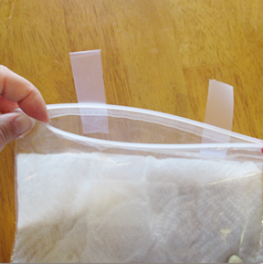
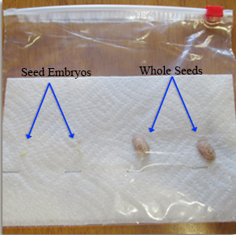

- Have the students fill out the Seed Science Experiment page.

- Have the students write their names on the bags with sharpies and place on a tray in a warm spot. Monitor for growth and finish the page a week later.

Planting Grocery Seeds
Using the seeds that were brought, set up a few pots for each seed with id tags.

Extensions: Give the students blank pieces of paper and instruct them to depict the process of growing a seed to a plant by drawing it.
Reading a Seed Packet Lesson,
Starting Plants in the Classroom Lesson
Ask students to research how to germinate the store-bought seeds that they brought.

Assessment:
If students journaled their observations in their science journal you can grade for inclusion of all suggested observations.
You can also consider assessing whether or not they participated.
You can easily extend this activity into reading or writing and assess based on those activities.
You can assess completion and accuracy of the worksheet

References
Books:
The Budding Botanist (AIMS Activities Grades 3-6) Investigations with Plants
by Evalyn Hoover, Howard Larimer, Sheryl Mercier, Michael Walsh, Dave Youngs and Beverly Tillman 2009 ISBN: 1-881431-40-1

The Classroom Hydroponic Plant Factory
by Foothills Hydroponics, inc. 2010 ISBN: 0-9669557-1-4

From Seed to Plant
by Gail Gibbons ISBN: 0-8234-1025-0 1991

Plant Plumbing: A Book About Roots and Stems (Growing Things)
by Susan Blackaby 2003 ISBN: 1-4048-0109-X; ISBN: 978-1-4048-0385-5

Tops & Bottoms
by Janet Stevens ISBN: 0-15-292851-0

What’s In The Garden?
By Marianne Berkes ISBN 978-1-58469-190-7

Websites
Illinois ACES College of Agricultural, Consumer and Environmental Sciences http://www.aces.uiuc.edu/vista/html_pubs/hydro/require.html

Gardening Know How https://www.gardeningknowhow.com/special/children/how-plants-grow.htm

Simply Hydroponics and Organics: http://www.simplyhydro.com/system.htm

